Roots Africa Data Dashboard Project Final Report

Bruck Getnet, Scott Chen, Demetrios Tzamaras, Rishabh Banga, Ildreed Mbami, Yosef Tsigie

University of Maryland - College Park

INST490: Integrated Capstone for Information Science

Professor Andrew Fellows

May 14, 2025

# Abstract

This project aimed to develop a comprehensive data monitoring dashboard to help Roots Africa track and showcase their community transformation efforts across Liberia and Uganda. Roots Africa, an NGO founded by Cedric Nwafor, works to end hunger and poverty through agricultural education and entrepreneurship development in Africa. Despite training over 11,000 farmers through 648 changemakers, the organization faced significant challenges in tracking, measuring, and communicating their impact due to the lack of a centralized data visualization system.

Our team of Information Science students, specializing in data visualization and dashboard development, collaborated with Roots Africa from January to May 2025 to address these challenges. Each team member contributed unique expertise: Rishabh Banga served as Project Manager, Bruck Getnet as Research Lead, Scott Chen as UX Designer, Demetri Tzamaras as Technical Lead, Yosef Tsigie as Data Analyst, and Ildreed Mbami as Client Lead.

The project evolved from an initial focus on basic data visualization to a more comprehensive solution that included standardized field data collection, interactive data visualization, and decision-making tools. Working closely with Cedric Nwafor and his team, we created a solution that aligned with Roots Africa's guiding philosophy: "Africa doesn't need charity, it needs changemakers."

# Methods

## Research and Planning

Our team began with extensive background research on Roots Africa, including its mission, operations, and specific data management challenges. We developed a detailed requirements document after conducting stakeholder interviews with Roots Africa's leadership. This included understanding their current data collection methods, reporting needs, and challenges in measuring impact across remote communities in Liberia and Uganda.

## Technology Selection

After speaking with Cedric and Roots Africa we were granted access to Kobo Collect for field data collection due to its robust offline functionality and suitability for areas with limited connectivity. For the dashboard development, we chose a web-based platform that integrated with Kobo Collect data and provided interactive visualization capabilities, ensuring scalability and ease of use for non-technical users.

Originally, we intended to use Tableau. However, due its complex interface and restricted collaboration capabilities we pivoted to Google Looker Studio. This alternative enabled us to collectively work on the dashboard simultaneously. Additionally, we exported the data from Kobo Collect to Google Sheets, which integrated seamlessly with Google Looker Studio.

### Development Process

* Initial Prototype Development: Created basic dashboard wireframes and survey forms
* Kobo Collect Configuration: Utilized the four survey types in Kobo Collect for developing the community dummy data
* Dashboard Development: Built interactive visualization components with geospatial mapping
* Integration: Connected Kobo Collect dummy data sources with dashboard visualizations
* Testing and Refinement: Conducted usability testing with Roots Africa staff

**Obstacles and Solutions**

* Technical Complexity: Integrating data collection with visualization posed significant challenges. We addressed this by creating middleware solutions that standardized data formats between systems.
* Connectivity Issues: Limited internet access in rural areas of Liberia and Uganda necessitated robust offline functionality. We prioritized offline data collection in Kobo Collect and implemented synchronization capabilities for when connectivity became available.
* Data Quality Concerns: Ensuring consistent data entry across field agents required standardization. We developed data validation procedures and comprehensive field agent training materials.
* Resource Constraints: Roots Africa's limited technical staff meant the system needed to be simple to maintain. We simplified the dashboard interface for non-technical users and created detailed documentation.
* Implementation Timeline: Balancing comprehensive features with project deadlines required careful prioritization. We adopted a phased implementation approach, focusing on core requirements first with a roadmap for future enhancements.

# Descriptions of Deliverables/Findings

**1) Data Collection System**

We implemented and configured Kobo Collect with four survey types designed to capture comprehensive community data:

* Community Resource Mapping: Surveys to document infrastructure, available services, natural resources, and financial services in each community
* Community Readiness Assessment: Tools to evaluate leadership structures, farmer groups, farming practices, and market access
* Community Maturity Assessment: Measurements of community-led initiative history, youth/women involvement, and problem-solving approaches
* Individual Household Surveys: Detailed information about income sources, farming techniques, food security, and training interests

The surveys were designed to work offline and synchronize when connectivity became available, addressing the technological constraints in rural areas.

**2) Interactive Dashboard**

The centerpiece of our deliverables was a comprehensive data dashboard with the following key features:

* Geospatial Mapping: Interactive maps showing community locations across Liberia and Uganda with color-coded indicators of maturity and readiness scores
* Community Comparison Visualization: Tools to compare different communities based on selected metrics
* Resource Gap Identification: Visualizations highlighting missing resources or infrastructure needs by region
* Training Impact Measurement: Metrics showing before/after changes resulting from training programs
* Data Export Capabilities: Functionality to extract data for external reporting to donors and stakeholders
* Filtering Options: Ability to filter data by region, maturity stage, crops, and other parameters

The dashboard interface was designed with a focus on simplicity and usability, ensuring that non-technical staff could navigate and interpret the data effectively.

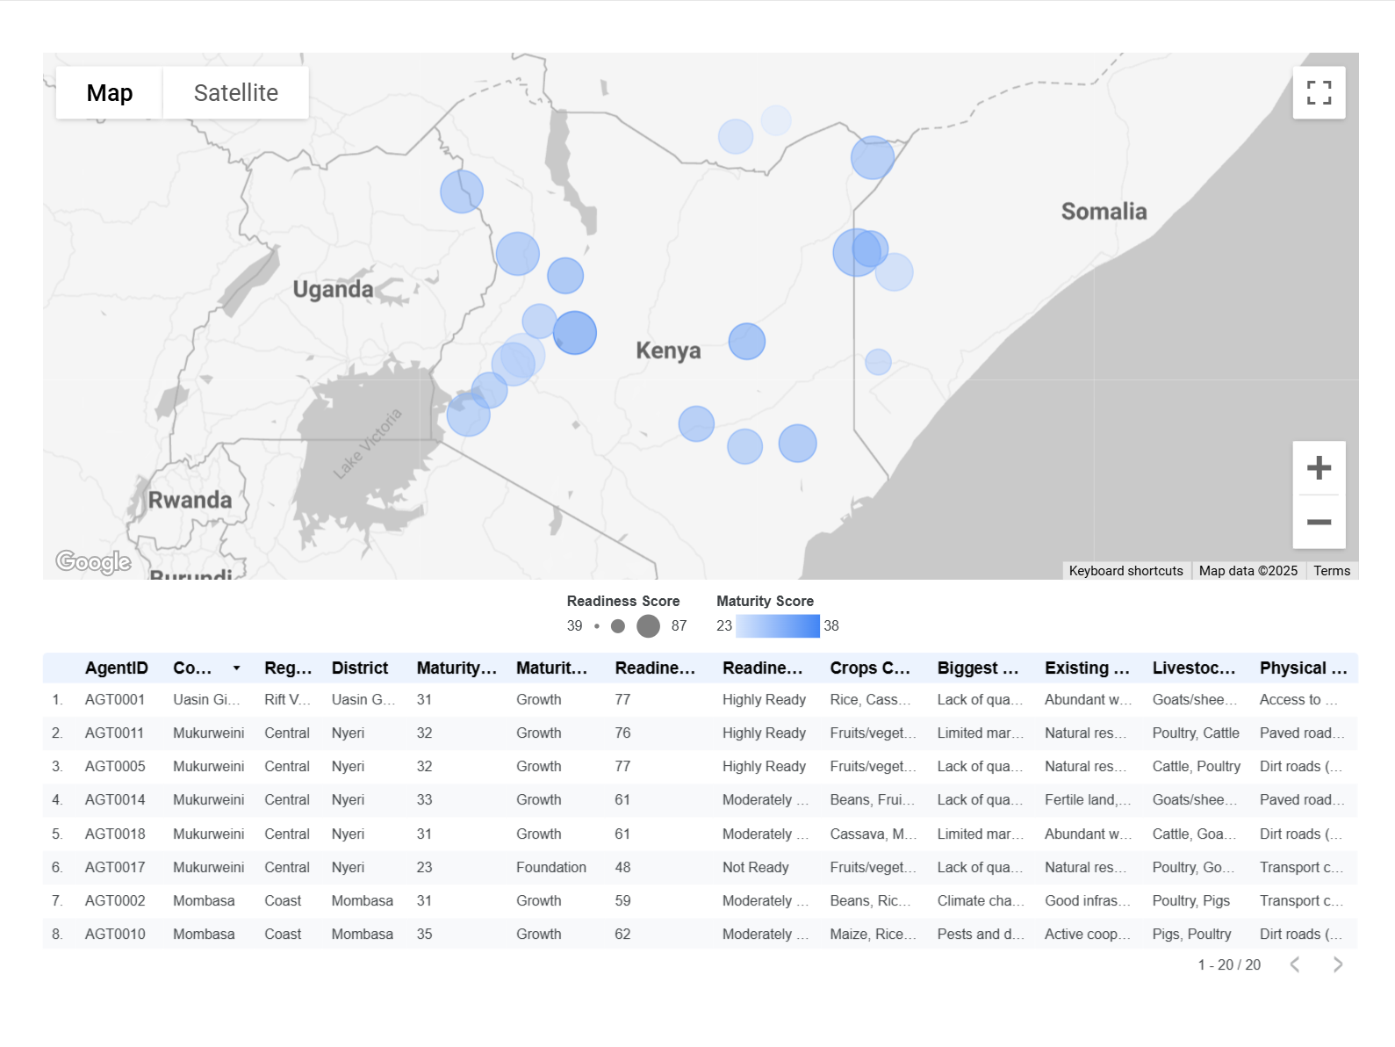

**3) User Documentation and Training Materials**

To ensure long-term sustainability of the system, we developed:

Administrator Guide: Technical documentation for maintaining the system, including data backup procedures, user management, and troubleshooting

Field Agent Manual: Illustrated guides for data collection using Kobo Collect, including offline usage procedures

Dashboard User Guide: Step-by-step instructions for navigating the dashboard, creating reports, and interpreting visualizations

Video Tutorials: Screen recordings demonstrating key workflows for visual learners

**4) Community Maturity and Readiness Assessment Framework**

Beyond the technical deliverables, we collaborated with Roots Africa to develop a standardized framework for assessing community maturity and readiness:

* Maturity Scoring System: A 0-50 scale evaluating community progress toward self-sufficiency
* Readiness Indicators: Metrics to identify communities most prepared for specific interventions
* Progression Pathway: Visual representation of the journey from initial engagement to community-led transformation

This framework provides both quantitative metrics and qualitative insights that help Roots Africa make informed decisions about resource allocation and program development.

## Key Findings

# Our analysis of the collected data revealed several important insights:

# Leadership Impact: Communities with stronger local leadership structures showed demonstrably faster progress in agricultural and entrepreneurial development

# Market Access Challenges: Access to markets remains a significant barrier in most regions, highlighting potential focus areas for infrastructure development

# Youth Involvement Correlation: Communities with higher youth involvement in agricultural programs demonstrated greater innovation rates and technology adoption

# Common Resource Gaps: Storage facilities and transportation infrastructure were consistently identified as critical lacking resources across communities

# Community Maturity Distribution: Most communities currently fall in the Growth stage (26-35 points on the maturity scale), indicating positive momentum but continued need for support

# These findings have already begun informing Roots Africa's strategic planning and resource allocation decisions.

# Recommendations

**Short-term Recommendations (3-6 months)**

* Complete Field Data Collection: We recommend that Roots Africa field agents complete data collection for all communities using the developed survey tools. Initially, this can be done with dummy data for testing the system before full implementation.
* Training Program: Develop a comprehensive training schedule for field agents and administrators to ensure consistent data collection and dashboard usage.
* Data Quality Audit: Implement regular data quality checks to identify and address any inconsistencies in the collected information.

**Medium-term Recommendations (6-12 months)**

* Advanced Analytics: Explore more sophisticated analytical capabilities to discover additional success factors and correlations between community characteristics and outcomes.
* Mobile Application Development: Consider developing a simplified mobile app version of the dashboard for increased accessibility by field agents and community leaders.
* Integration with External Data Sources: Incorporate relevant external data such as weather patterns, market prices, and agricultural research to provide additional context and insights.

**Long-term Vision (1-3 years)**

* Community-facing Dashboard: Develop a simplified dashboard version accessible to local community leaders, enabling them to track their own progress and make data-informed decisions.
* Predictive Analytics: Implement predictive modeling to help identify communities with high potential for success based on patterns observed in historical data.
* Regional Expansion: Scale the system to accommodate Roots Africa's expansion into additional countries, with localization features for different languages and agricultural contexts.

The long-term vision is for communities themselves to use data to drive their own transformation, aligning with Roots Africa's core philosophy of creating changemakers rather than dependency.

# Conclusion

The Roots Africa Data Dashboard project has successfully transformed how the organization monitors, evaluates, and communicates its impact across communities in Liberia and Uganda. By implementing standardized data collection through Kobo Collect and creating an interactive visualization dashboard, we've addressed Roots Africa's critical need for data-informed decision-making.

The system now allows Roots Africa to:

* Track community progress through different maturity stages
* Identify communities most ready for specific interventions
* Measure and demonstrate impact to donors and stakeholders
* Optimize resource allocation based on evidence
* Support the ongoing training and development of changemakers

While the delivered system meets Roots Africa's current needs, we recognize that this is just the beginning of their data journey. The recommendations outlined above provide a roadmap for continued enhancement and expansion of these capabilities.

For questions or additional information about this project, please contact the team members:

* Rishabh Banga (Project Manager): rbanga@terpmail.umd.edu
* Bruck Getnet (Research Lead): bgetnet@terpmail.umd.edu
* Scott Chen (UX Designer): schen519@terpmail.umd.edu
* Demetri Tzamaras (Technical Lead): dititza@terpmail.umd.edu
* Yosef Tsigie (Data Analyst): ytsigie@terpmail.umd.edu
* Ildreed Mbami (Client Lead): ildreed@terpmail.umd.edu

**Deliverables**

Google Drive Folder of all our work: <https://drive.google.com/drive/folders/1iz1ofKkp6yWtNYGJSAbcYryPVvLao25d?usp=drive_link>

Data Dashboard: <https://lookerstudio.google.com/u/0/reporting/8ca44803-9157-475f-9132-665546ccf4c3/page/o52HF>